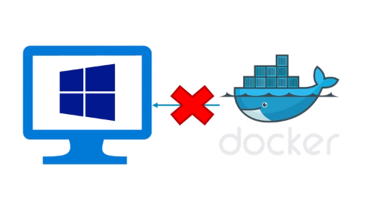

Docker uses features of Linux which windows don’t supports. 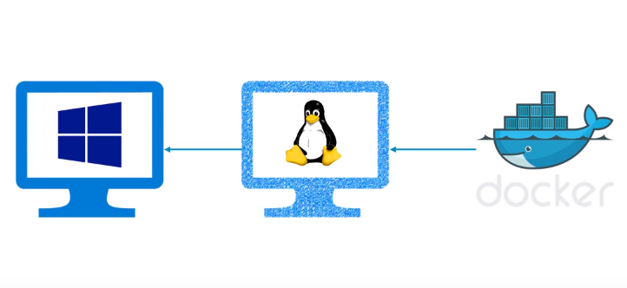

Therefore we need a virtual machine running linux and your docker will run on that VM, and windows can control it.

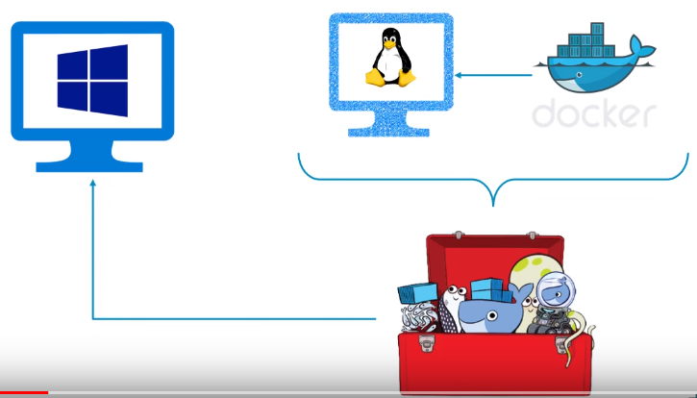

But Docker guys have prepared Docker Toolbox which takes care of this infrastructure.

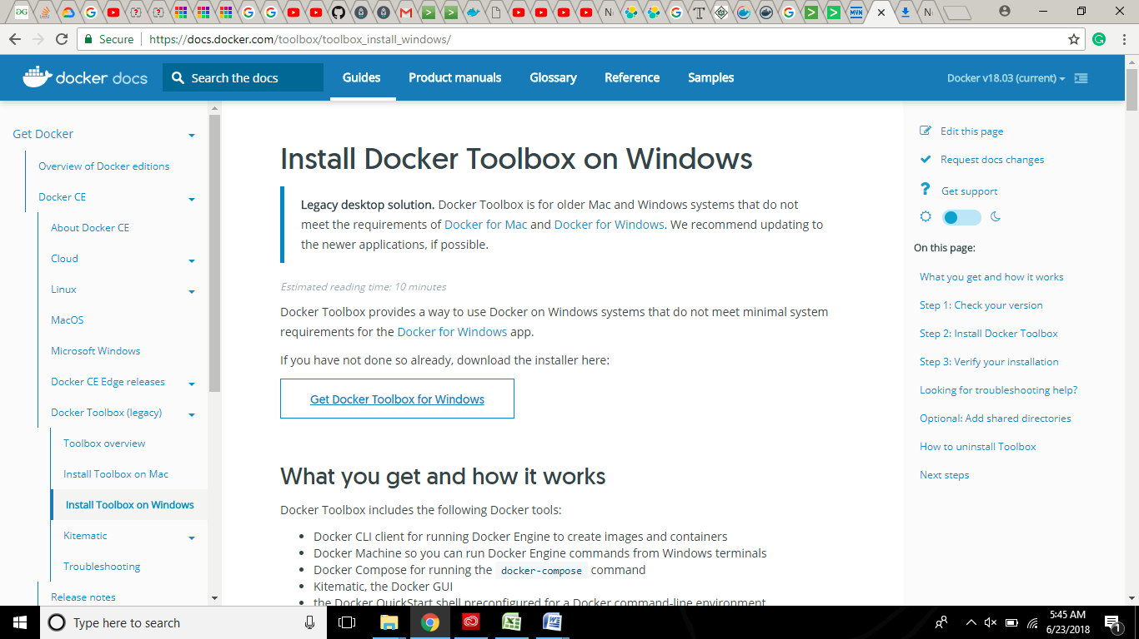

**I think** when we install Docker Toolbox these Environmental Variables get automatically set !

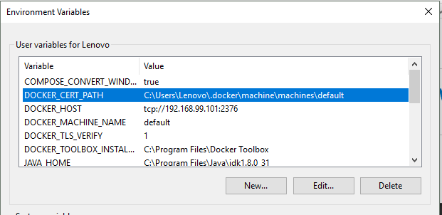

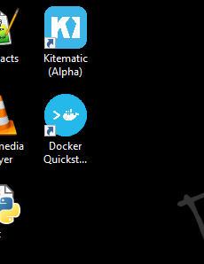

Click on docker Quickstart

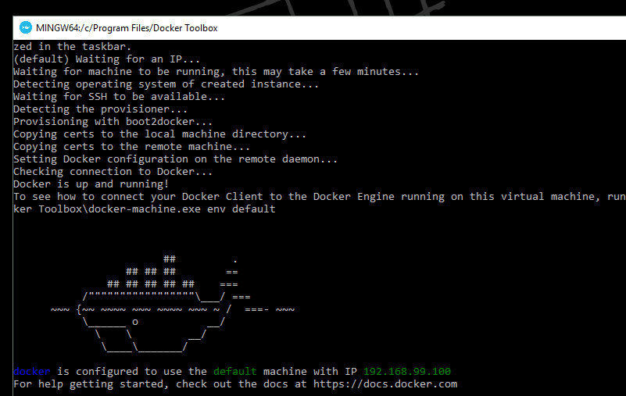

JAVA-------DOCKER

Create a folder and keep two files into it – Hellodocker.java + Dockerfile

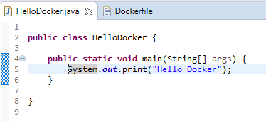

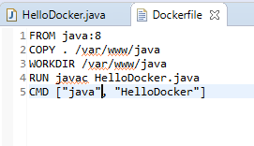

Navigate till the folder, where these files are kept [**In Docker Quickstart Terminal**]…



Verify:

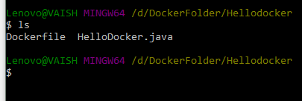

Now, execute the below commands:

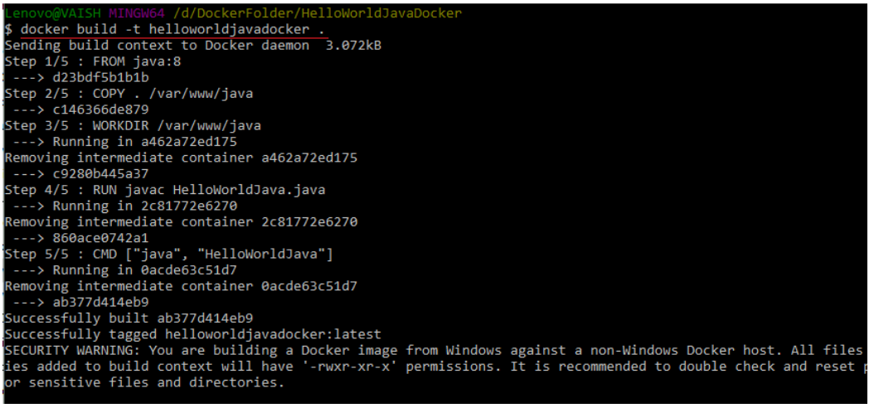

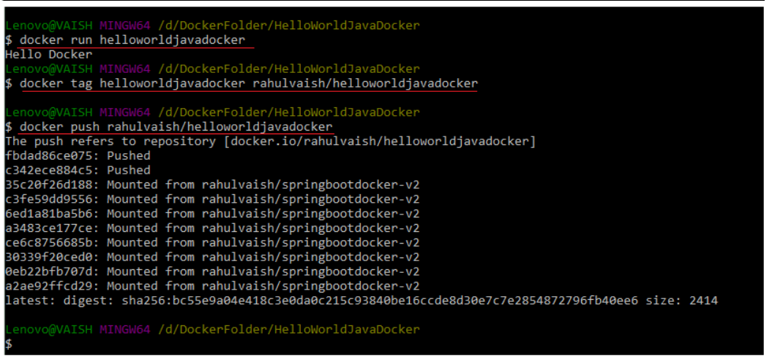

Now, if we check the HUB !!!

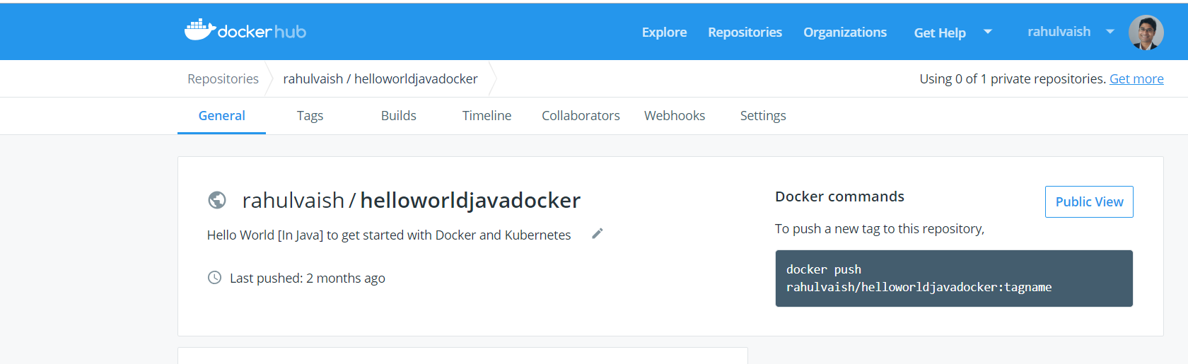

Next time, if you want to use HelloDocker, its easy:

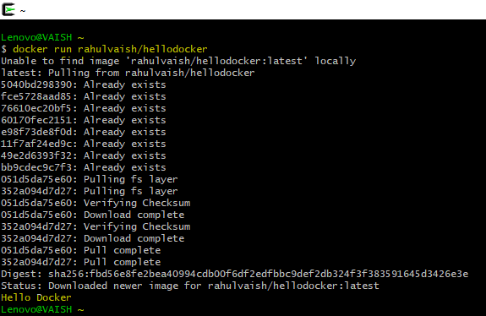

**Additional Miscellaneous Information:**

After this, we can see in the toolbox docker guys have provided us with an image - an .iso file called boot2docker. We can use this iso image in our VMWare ☺

But,

